A Project Proposal On

**Underground Transmission Line Fault**

**Detection Using Radial Basis Function Neural Network**



Bishad Upadhyay [20480091]

Narayan Bahadur Rana [20480096]

Pradip Subedi [20480097]

Sneha Kumari Singh [20480102]

Subash Sharma [20480103]

**United Technical College**

**Faculty of Science and Technology**

**Affiliated to Pokhara University, Nepal**

**January 2024**

# Declaration

We hereby declare that this study entitled “**Underground Transmission Line Fault Detection Using Radial Basis Function Neural Network**” is based on our original work. Related works on the topic by other researchers have been duly acknowledged. We owe all the liabilities relating to the accuracy and authenticity of the data and any other information included hereunder.

**Name of the Students:**

BISHAD UPADHYAY

NARAYAN BAHADUR RANA

PRADIP SUBEDI

SNEHA KUMARI SINGH

SUBASH SHARMA

Date: 24th, JAN 2024

# Certificate of Project Proposal Approval

This project entitles **“Underground Transmission Line Fault Detection Using Radial Basis Function Neural Network”** proposed by the students Bishad Upadhyay, Narayan Bahadur Rana, Pradip Subedi, Sneha Kumari Singh & Subash Sharma of United Technical College under the department of Electrical and Electronic Engineering has been submitted as per the content, style and format proposed by research and development. The project has been feasible and thus has been approved.

………………………………

Department Head of Electrical and Electronics Engineering,

Er. Bikal Baral

United Technical College

Bharatpur-11, Chitwan

# Abstract

This project proposed a fault localization model for the underground Transmission lines with RBFNN. Detecting fault source is difficult because the entire line must be dug to check fault at cable line. A fault might occur due to many reasons such as digging, earthquake, construction work, etc. The maintenance process related to that particular line is difficult due to the unknown location of the fault in the line. In this project, an effective fault location technique will be proposed.

In this project a new automated fault location method by using radial basis function neural network (RBFNN). First determines the type of fault, Furthermore, an using radial basis function neural network (RBFNN) will be trained for each type of fault. The RBFNN are trained to estimate the fault distance to the substation. The Inputs of the RBFNN are data of 3-phase voltages, currents, and active powers of the feeder are measured at the substation in pre-fault and fault stages. The suggested approach is able to determine the accurate type and location of faults using RBFNN in a MATLAB based developed software. The proposed method is tested on the IEEE 34-bus test feeder. Each RBFNN will be train by operating patterns. The train RBFNNs can estimate fault distance to the substation; even the structure of the distribution network is changed. The proposed method will be effective while the input data contains errors of measuring.

***Keywords:*** *Fault location, Distribution feeder, IEEE 34 bus test feeder, Radial Basis Function Neural Network (RBFNN)*

# Contents

Declaration i

Certificate of Project Proposal Approval ii

Abstract iii

Contents iv

List of figures vi

List of Tables vii

List of Abbreviations viii

CHAPTER ONE 1

1.1. Background 1

1.2. Introduction 1

1.3. Underground Cable 2

1.3.1. Faults in Underground Cable 3

1.4. Artificial Neural Network 4

1.4.1. ANN Fault Detection Technique 4

1.6. Statement of Problem 6

1.7. Research Objectives 7

1.8. Significance of Study 7

1.9. Limitations of the Study 7

1.10. Scope and Application of the project 8

CHAPTER TWO 9

LITERATURE REVIEW 9

2.1. RBFNN Structure 11

2.2. Identifying the Fault Types 13

CHAPTER THREE 15

RESEARCH METHODOLOGY 15

3.1. RBFNN Training 15

3.2. Detection of Fault 16

3.3. Determining the Fault Location 16

3.4. Single Line Diagram 17

3.5. Flow Chart 17

CHAPTER FOUR 20

EXPECTED OUTCOME 21

CHAPTER FIVE 22

WORK SCHEDULE 22

5.1. Gantt Chart 23

CHAPTER SIX 24

BUDGET 24

CHAPTER SEVEN 25

REFERENCES 25

Appendix 1 27

# List of figures

Figure 1.1: Open Circuit Fault 3

Figure 1.2: Short Circuit Fault 4

Figure 1.3: Earth Faults Damage to Outer Sheath 4

Figure 2.1: Model Of RBFNN 12

Figure 3.1: Process of Methodology 15

Figure 3.2: Single Line Diagram 17

Figure 3.3: Snapshot of the studied model in SimPowerSystems 17

Figure 3.4: Flow Chart (field Study, 2024) 19

Figure 5.1: Gantt chart of Work Schedule (Field Work 2024) 23

Figure 6.1: Budget Plan (field work 2024) 24

# List of Tables

Table 1.1 : Comparison of ANN Types 6

Table 2.1 : Fault Types Classification Data 13

# List of Abbreviations

|  |  |
| --- | --- |
| ADC | Analog to Digital Converter |
| AI | Artificial Intelligences |
| ANN | Artificial Neural Network |
| CNN | Convolutional Neural Network |
| DC | Direct Current |
| DG | Distributed Generation |
| FDANN | Fault Detection Artificial Neural Network |
| FIS | Fuzzy Inference System |
| FNN | Feedforward Neural Network |
| GAN | Generative Adversarial Network |
| IEEE | Institute of Electrical and Electronics engineer |
| IoT | Internet of Things |
| IR | Insulation Resistance |
| LSTM | Long Short-Term Memory |
| MATLAB | Matrix Laboratory |
| MLP | Multi-Layer Perceptron |
| RBF | Radial Basis Function |
| RNN | Recurrent Neural Network |
| RBFNN | Radial Basis Function Neural Network |
| SVM | Support Vector Machine |
| TDR | Time Domain Reflectometry |
| UTL | Underground Transmission Line |

# CHAPTER ONE

## 1.1. Background

Electricity is the lifeblood of modern civilization, and how it is transmitted and distributed has evolved significantly over time. Traditionally, overhead cables suspended on pylons were the primary method for transmitting electrical power across distances. However, as technology progressed and urban areas expanded, the limitations of overhead cables, such as susceptibility to weather conditions and visual impact on the landscape, became apparent.

Underground cables transformed power transmission. These cables were useful, especially in busy cities, as they looked better, were safer, and less affected by the weather. They provided a more secure and dependable way to distribute power because they were placed underground and protected from outside influences[3].

Detecting faults in underground cables is complex due to the hidden nature of these systems. Unlike their overhead counterparts, where faults are often visually detectable, faults in underground cables are concealed and require specialized methodologies for identification and rectification. Traditional fault detection systems, while effective, often lack precision and can lead to prolonged downtimes, impacting vital services reliant on uninterrupted power supply [4].

This underscores the pressing need for advanced and accurate fault detection methods tailored for underground power cable systems. These methods should enable swift and precise identification of faults, minimizing downtime and ensuring efficient power restoration. The development of such methodologies aligns with the continuous exploration to enhance the reliability and flexibility of power distribution networks [5].

## 1.2. Introduction

In the present scenario when the power demand is increasing along with the increase in the population hybrid transmission will be the solution when there is the constraint of right of way in densely populated areas. This combination can also be implemented to connect the existing grids with the offshore wind farms with better reliability. To make the system operate successfully the response to the fault for the detection and location purpose should be minimal. This helps to reduce the time required to restore the system to normal condition. Thus, with the advancement in technologies future power grids can be implemented with relays employing knowledge-based techniques. Thus, with the advancement in the technologies future power grids can be implemented with relays employing the knowledge-based techniques [1]. [Underground transmission lines are electrical**or telecommunication cables are installed beneath the**](https://www.bing.com/ck/a?!&&p=cef242e7482088afJmltdHM9MTcwNDY3MjAwMCZpZ3VpZD0xYmM4MmI0My03MmYxLTZlOWItMDA3Ni0zODU3NzNmMDZmNWImaW5zaWQ9NTc1NA&ptn=3&ver=2&hsh=3&fclid=1bc82b43-72f1-6e9b-0076-385773f06f5b&psq=introduction+of+underground+transmission+line&u=a1aHR0cHM6Ly93d3cudHJlbmNobGVzc3BlZGlhLmNvbS9kZWZpbml0aW9uLzMzNTMvdW5kZXJncm91bmQtdHJhbnNtaXNzaW9uLWxpbmVz&ntb=1)ground. They are used to transmit power through populated areas, underwater and other places where overhead transmission lines are difficult to used. Underground transmission lines are insulated to protect them from water and other contaminants. It is installed between the line and ground at each substation.

There are many causes of faults in power transmission leading to power outages, if not properly managed. Large natural gas pipelines are also called transmission lines, but the term underground transmission lines are normally used to distinguish underground from overhead cabling. Underground lines also have some advantages. They are less affected by weather conditions, and they offer higher reliability and security than overhead lines. They are also less prone to interference from external factors, and they reduce the risk of electrocution or injury to people or animals. As we know all transmission lines consist of faults due to cable insulation failure or joint insulation failure as a direct result of different partial discharge forms inside the cable or the joint. There are some faults that occur in underground transmission lines i.e., short circuit, open circuit, and earth fault [2].

## 1.3. Underground Cable

An underground cable refers to a type of electrical cable that is installed below the ground surface for the purpose of transmitting electricity or telecommunication signals. This method of cable installation offers several advantages over overhead cables, including reduced visual impact, enhanced safety, and protection from environmental elements. Underground cables are commonly used in urban areas, densely populated regions, and areas where aesthetic concerns or safety considerations make overhead cables impractical.

Key features of underground cables include their insulation, which protects the conductors from moisture, chemicals, and other external factors. The insulation also helps prevent electrical leakage and ensures the efficient transmission of power or signals. Underground cables may consist of various materials, including copper or aluminum conductors surrounded by insulating layers, metallic shielding, and a protective outer sheath. These cables are employed for various applications, such as distributing electrical power to homes, businesses, and industrial facilities, as well as for telecommunications, providing the infrastructure for telephone lines, internet cables, and other communication services. The installation of underground cables involves digging trenches or utilizing other specialized methods to bury the cables beneath the ground.

While underground cables offer numerous advantages, such as reliability and improved aesthetics, they also present challenges in terms of installation, maintenance, and repair. Locating and fixing faults in underground cables can be more complex and time-consuming compared to overhead cables. Nonetheless, the benefits often outweigh the challenges, making underground cables a common and essential component of modern electrical and communication networks.

### 1.3.1. Faults in Underground Cable

Faults in underground transmission lines can pose significant challenges due to the concealed nature of the cables. These faults can disrupt the flow of electrical power, leading to outages or other issues. Several factors can contribute to faults in underground transmission lines.

* **Open Circuit Fault:**

An open circuit fault in underground cables refers to a situation where there is a discontinuity or break in the electrical circuit, preventing the flow of current. In this type of faults, the three conductors of a-core cable at the far end are shortened, and then connected to the ground.

Figure 1.1: Open Circuit Fault

Break

Break

* **Short Circuit Fault:**

A short circuit fault in underground cables occurs when there is an unintended connection between two conductors with different potentials, resulting in a sudden and excessive flow of current. This abnormal current flow can lead to various issues, including damage to the cable insulation, equipment, or even a disruption of the electrical system.

Short

Figure 1.2: Short Circuit Fault [23]Short

Figure 1.2: Short Circuit Fault

* **Earth Fault:**

An earth fault in underground cables occurs when one or more of the conductors (wires) unintentionally come into contact with the ground or any conductive part that is connected to the ground. Unlike a short circuit, where two conductors with different potentials connect, an earth fault involves a connection between a conductor and the Earth (ground). This situation can lead to various issues and poses safety risks [5].

Conductor

Conductor

Insulation

Insulation

Damage to outer sheath

Figure 2: Earth FaultsDamage to outer sheath

Outer sheath

Outer sheath

Figure 1.3: Earth Faults

## 1.4. Artificial Neural Network

Artificial Neural Networks (ANNs) are computational models inspired by the structure and functioning of the human brain. There are various types of artificial neural networks, each designed for specific tasks and applications. Here are some common types Multilayer Perceptron (MLP), Convolutional Neural Networks (CNN), Recurrent Neural Networks (RNN), Generative Adversarial Network (GAN) and Auto encoders.

### 1.4.1. ANN Fault Detection Technique

For fault detection in underground transmission lines, various types of artificial neural networks (ANNs) can be employed, depending on the specific requirements and characteristics of the data. Here are a couple of types commonly used for fault detection in power systems, including underground transmission lines.

* **Feedforward Neural Networks (FNN), particularly Multilayer Perceptron’s (MLP)**

MLPs are versatile and widely used for fault detection in power systems, including underground transmission lines. They can handle complex relationships within the data and are suitable for both classification (normal operation vs. fault) and regression tasks (estimating fault location or severity). The network is trained on historical data, including features extracted from sensor measurements, to learn the patterns associated with normal and faulty conditions.

* **Recurrent Neural Networks (RNN) and Long Short-Term Memory (LSTM):**

RNNs, especially LSTM variants, are effective for handling sequential data, making them suitable for fault detection in time-series data from sensors in power systems. They can capture temporal dependencies and patterns that may indicate faults. LSTM networks are known for addressing the vanishing gradient problem, making them especially useful for longer sequences of data.

* **Convolutional Neural Networks (CNN):**

CNNs are adept at processing grid-like data, such as images or spectrograms, which can be relevant for fault detection in power systems. For instance, CNNs can be applied to analyze patterns in frequency-domain data obtained from power system measurements. They are often used when spatial relationships within the data are crucial for fault identification.

* **Hybrid Approaches (Combining Different Types of Networks):**

Some applications may benefit from hybrid approaches that combine multiple types of neural networks. For instance, a combination of CNNs for spatial pattern recognition and LSTM networks for temporal dependencies might provide a more comprehensive solution for fault detection in underground transmission lines.

Table 1.1: Comparison of different ANN Types



There are various types of artificial neural networks (ANNs) can be employed, depending on the specific requirements and characteristics of the data. In this project we can used Radial Basis Function Neural Network (RBFNN).

RBFNN is considered to be a better neural network model for solving engineering problems. The proposed scheme determines the fault type by normalizing the fault current of the main source whereas the location of faults is determined by using two RBFNNs. The first RBFNN determines the fault distance from each UTL's and the main source while the second RBFNN identifies the exact faulty line.

## 1.5. Statement of Problem

Till the last decade the cables are made to place on overhead and currently a day’s mostly uses land cables. There are some techniques in overhead cables like phasor gauge system which is able to identify the accurate location of faults and its types. Underground cables are essential in some places particularly in cities, Airports and defense services. We can't easily identify the faults in underground cables.

The current fault detection methods employed in underground cable networks, which experience various faults such as short circuits, open circuits, and earth faults, are limited in their ability to identify these issues swiftly and precisely. Existing methods may result in disruptions and safety risks due to their inherent inability. Thus, it is crucial to address this challenge by developing and implementing advanced fault detection methodologies. Artificial Neural Networks (ANNs) offer a promising solution due to their ability to leverage complex data patterns and provide accurate fault detection. Therefore, the project proposal aims to utilize RBFNNs to improve the reliability, accuracy, and safety of underground cable networks.

## 1.6. Research Objectives

* To detect the Underground transmission line fault.
* To evaluate the effectiveness of Radial basis function neural network (RBFNN) by comparing with real fault location.

## 1.7. Significance of Study

The proposed research holds great significance in power distribution and infrastructure maintenance. By focusing on the development of a MATLAB-based simulation model for fault detection in underground power cable systems, this study aims to benefit various stakeholders:

* **Utility Companies and Operators:** Enhanced fault detection mechanisms will lead to reduced downtime, improved reliability, and increased efficiency in power distribution networks, resulting in cost savings and better service provision.
* **Maintenance Personnel and Engineers:** The study's outcomes will equip maintenance teams and engineers with advanced tools and methodologies for swift and accurate fault detection, allowing proactive measures to prevent service interruptions and enhance system resilience.
* **Urban Infrastructure and Residents**: Improved fault detection in underground cables ensures uninterrupted power supply, fostering safety, and reliability in urban environments, benefiting businesses, households, and essential services.
* **Researchers and Academia:** The research findings will contribute to the existing body of knowledge in fault detection methodologies, providing a basis for further research and advancements in the field of power systems engineering.

## 1.8. Limitations of the Study

While the proposed study endeavors to provide innovative solutions for fault detection in underground power cable systems, it's essential to acknowledge certain limitations:

* **Limited Field Validation:** The findings derived from simulations may require field validation to ensure their applicability and performance in practical scenarios, which might pose logistical challenges.
* **Model Generalizability:** The developed MATLAB model might be specific to certain cable configurations or fault types, limiting its generalizability to diverse scenarios.
* **Practical Implementation**: Difficult to implement in field due to losses.

## 1.9. Scope and Application

This project's scope is intended to detect the short-circuit fault in an underground cables and abnormalities in the electrical signal with associated with cable system. To develop a continuous real-time condition monitoring and control system for electricity in urban areas. Since this project is intended to detect faults, it is crucial. What makes it highly special is that it saves human lives, especially patients which are unrecoverable if once lost through electricity shortage; this project also saves humans from losses of their properties due to electricity problems. For underground distribution network’s fault location and state estimation is very challenging. Work may help in some degree to support further analytical and practical studies in the field of fault location and state calculation for real underground distribution system. Finally, the highest priority is given to the software design to develop a suitable algorithm that will promptly interact with RBFNN.

# CHAPTER TWO

# LITERATURE REVIEW

In the modernization world, underground cable is more effective than overhead transmission lines. The history of underground cable dates to the 19th century, and their development has been closely tied to the evolution of electrical engineering and the need for reliable and safe distribution of electricity. They can be insulation failure due to improper maintenance, objects falling on overhead lines, and lines falling on earth. If temporary faults are not cleared, eventually, they will change into permanent faults sooner [10].

There are three types of faults, i.e., line-to-ground, line-to-line, and line-to-ground faults. Nowadays, cable faults are the most severe, and that's why most scholars focus on this idea. Lakshmi M, discussed the Sectionalizing method in 1959. This procedure risks reducing cable reliability because it depends on physically cutting and splicing the cable. Dividing the cable into successively smaller sections and measuring both ways with an ohmmeter or high-voltage Insulation resistance (IR) tester enables narrowing down the search for a fault. This laborious procedure normally involves repeated cable excavation. Touaibia discussed the Time Domain Reflectometry (TDR) method in 2001: The TDR sends a low-energy signal through the cable, causing no insulation degradation [11].

A theoretically perfect cable returns that signal in a known time and in a known profile. Impedance variations in a 'real-world' cable alter both the time and profile, which the TDR screen or printout graphically represents. One weakness of TDR is that it does not pinpoint faults. Dhekale.P.M discussed the Murray loop test method in 2006. It is a bridge circuit used for locating faults in underground or underwater cables. It uses the principle used in a potentiometer experiment. One end of the faulted cable is connected through a pair of resistors to the voltage source. Also, a null detector is connected. The other end of the cable is shorted [12].

Raghu Raja Kalia discussed the Varley loop test method in 2010: If the fault resistance is high, the sensitivity in the Murray Bridge is reduced, and Varley loop may be more suitable, but only a single fault exists. Artificial Neural Networks (ANNs) are computational models inspired by the human brain's neural structure, capable of learning complex patterns from data [13].

The use of ANNs in fault detection supports their ability to adapt and generalize from training data to identify patterns associated with faults. ANNs have demonstrated positive results in terms of accuracy, greater efficiency of faults detection and speed compared to traditional methods. Literature covers various types of faults, including short circuits, leakage faults, and breaks in cables or pipelines. Combining multiple ANNs or other techniques may be explored. Challenges in terms of limited labeled data, model interpretability, and real-time implementation are discussed. Future directions may involve the integration of advanced technologies such as IoT, edge computing, and explainable AI to enhance fault detection systems [14].

Asumadu, J., Real-world case studies and practical implementations of ANN-based fault detection systems are presented to showcase the effectiveness and feasibility of the proposed models. The proposed method is tested on IEEE 34-bus test feeder successfully. The outputs of the ANNs for operating test patterns, not presented in the training stage, are shown the accuracy of the ANNs. The literature review concludes by summarizing key findings and suggesting potential areas for further research in the field of underground fault detection using artificial neural networks [15].

Other similar project which are using ANN method. Fuzzy interface systems (FIS), FIS operate the principle of Boolean logic, fuzzy logic allows the degree of truth to be indicated by value in the range [0,1], zero represented by the absolute falsity and one represented absolute truth [19].

Support vector machine SVM was invented by Cortes and Vapnik in 1995, the theoretical foundation and the main idea of SVM classifiers is to find an optimal hyperplane that maximizes the margin between two groups of examples. The advantages of SVM made it a powerful tool for fault classification in transmission lines and distribution systems [20].

Several projects in underground transmission line fault detection have used traditional methods like Sectionalizing, Time Domain Reflectometry (TDR), and the Murray loop test. These methods require physical cable intervention, and while effective, may lack pinpoint accuracy in locating faults. Conversely, the focus of the proposed project lies in using Artificial Neural Networks (ANNs) for fault detection. This approach involves training ANNs for different fault types without relying on consumer load data. The project aims to cover the entire network operating space by diversifying training patterns.

Compared to conventional methods, the project's reliance on RBFNNs promises more accurate fault distance estimation even with input data errors. It also addresses challenges like limited labeled data, hinting at future integrations of advanced tech for enhanced fault detection systems. Ultimately, this approach represents a promising leap in fault detection for underground transmission lines.

Broomhead and Lowe's 1988 seminal paper radial basis function networks (RBF) networks have traditionally been associated with radial functions in a single-layer network. A Radial Basis Function is a real-valued function, the value of which depends only on the distance from the origin. Although we use various types of radial basis functions, the Gaussian function is the most common [23].

In the instance of more than one predictor variable, the Radial basis Functions Neural Network has the same number of dimensions as there are variables. If three neurons are in a space with two predictor variables, we can predict the value from the RBF functions. We can calculate the best-predicted value for the new point by adding the output values of the RBF functions multiplied by the weights processed for each neuron. The radial basis function for a neuron consists of a center and a radius (also called the spread) [22].

### 2.1. RBFNN Structure

The RBFNN is a feed-forward neural network consisting of three layers, namely, an input layer which feeds the values to each of the neurons in the hidden layer, a hidden layer which consists of neurons with radial basis activation functions and an output layer which consists of neurons with linear activation function. The typical architecture of a radial basis functions neural network consists of an input layer, hidden layer, and summation layer. A generic architecture of an RBFNN with *k* input and *m* hidden neurons is shown in Figure 2.1



Figure 2.1: Model Of RBFNN [20]

**Input Layer:** The input layer consists of one neuron for every predictor variable. The input neurons pass the value to each neuron in the hidden layer. N-1 neurons are used for categorical values, where N denotes the number of categories. The range of values is standardized by subtracting the median and dividing by the interquartile range.

**Hidden Layer:** The hidden layer contains a variable number of neurons (the ideal number determined by the training process). Each neuron comprises a radial basis function centered on a point. The number of dimensions coincides with the number of predictor variables. The radius or spread of the RBF function may vary for each dimension.

When an x vector of input values is fed from the input layer, a hidden neuron calculates the Euclidean distance between the test case and the neuron's center point. It then applies the kernel function using the spread values. The resulting value gets fed into the summation layer.

**Output Layer or Summation Layer:** The value obtained from the hidden layer is multiplied by a weight related to the neuron and passed to the summation. Here the weighted values are added up, and the sum is presented as the network's output. Classification problems have one output per target category, the value being the probability that the case evaluated has that category [22].

### 2.2. Identifying the Fault Types

To identify the various fault types, namely, single phase to ground fault, phase to phase fault, two phase to ground fault and three phase faults, the 3 phase currents of the main source from the feeding substation are used. The three phase output fault currents at the main source or the feeding substation are normalized by considering the maximum fault currents for each type of fault. To normalize the mentioned currents, the following equation is used:

$Inormal=\frac{I}{Imax}$ (1)

Where I is the fault current and Imax is the maximum fault currents for each type of fault.

Based on the normalized three phase fault currents, the fault types are classified as shown in table 2.1.

Table 2.1: Fault Types Classification Data

|  |  |  |  |  |  |
| --- | --- | --- | --- | --- | --- |
| Fault type |  | Ia | Ib | Ic | g |
| 1-phase to ground | Ag | 1 | 0 | 0 | 1 |
| Bg | 0 | 1 | 0 | 1 |
| Cg | 0 | 0 | 1 | 1 |
| phase to phase | AB | 1 | -1 | 0 | 0 |
| AC | 1 | 0 | -1 | 0 |
| BC | 0 | 1 | -1 | 0 |
| 2-phase to ground | ABg | 1 | 1 | 0 | 1 |
| ACg | 1 | 0 | 1 | 1 |
| BCg | 0 | 1 | 1 | 1 |
| 3 -phase | ABC | 1 | 1 | 1 | 0 |
| 3-phase to ground | ABCg | 1 | 1 | 1 | 1 |

From the table, “1”, “-1” and “0”, indicate that a fault occurs in the phase, a fault occurs in the phase but the short circuit current is in the opposite direction and no fault, respectively.

In the training of the RBFNN, the following computations are considered. When the network receives a *k* dimensional input vector *X*, the network computes a scalar value using,

*Y* =*f(X)* =*w0*  (2)

Where *w*0 is the bias, *wi* is the weight parameter, *m* is the number of nodes in the hidden layer and *(Di)* is the RBF.

In this study, the Gaussian function is used as the RBF and it is given by

$∅\left(Di\right)=\exp\left(\frac{D2}{σ^{2}} \right)$ (3)

Where σ is the radius of the cluster represented by the center node, *Di* is the distance between the input vector *X* and all the data centers.

The Euclidean norm is normally used to calculate the distance, *Di* which is given as

*Di=* (4)

Where *C* is a cluster center for any of the given nodes in the hidden layer [7].

# CHAPTER THREE

# **RESEARCH METHODOLOGY**

The project aims to support an Artificial Neural Network (ANN) for fault location detection in underground cable lines. Instead of relying only on the standard concept of ohms’ law, this approach involves training an RBFNN to identify fault locations based on input data derived from sensor readings. The artificial neural network (ANN) is a useful tool for identifying, isolating and classification of transmission faults. Identification, categorization, and localization of fault play a significant part in underground transmission line. An RBFNN will be employed to analyze patterns in the voltage changes across the cable lines when subjected to a low DC voltage through a series resistor. And the fluctuations in current due to the location of a fault in the short-circuited cable will be captured by the RBFNN. Sensor data from voltage changes will be fed into the RBFNN through an Analog-to-Digital Converter (ADC) to generate precise digital information [10].

Figure 3.1: Process of Methodology

## 3.1. RBFNN Training

Several different training algorithms for RBFNN are available on [20]. All these algorithms use the gradient of the performance function to determine how to adjust the weights to minimize performance. The gradient is determined using a technique called backpropagation, which involves performing computations backwards through the network. Taking speed and memory allocation into account many algorithms are available for implementing the backpropagation method. Levenberg-Marquardt optimization technique is used in the implemented RBFNN structure [21]. Simulations were done for different fault scenarios to get various fault patterns. The system model as well as RBFNN training was performed using MATLAB.

## 3.2. Detection of Fault

Detecting problems in underground cables using a Radial Basis function Neural Network (RBFNN) follows a step-by-step process. First, we gather information about how the cables normally work and what happens when things go wrong. We collect data about changes in power and other signals at different points along the cables. Next, we organize and clean up this data, making sure we're not missing any important bits. The most important parts of this data show when there might be a problem with the cables [12].

Then comes the important part: learning the RBFNN to understand this data. Project show the RBFNN lots of examples of both normal cable behavior and when there's a problem. The RBFNN learns from these examples and understands the differences. After learning the RBFNN, we check to see if it's good at finding problems using new examples it hasn't seen before [17].

If it does well, putting it into a system that keeps an eye on the cables all the time, and if something strange happens on the cables, the RBFNN recognizes it and tells the system. This helps quickly fix any issues. [18].

Training the RBFNN with new information to make sure it stays good at finding problems in the cables, even when things change. This continuous training and improvement helped the RBFNN get better at spotting cable issues over time.

## 3.3. Determining the Fault Location

RBFNN is use for specifying the exact location of the fault. Therefore, after recognizing the fault type by corresponding unit, the trained RBFNNs of this kind of fault is activated and receives the input data, which has been prepared by the input data preparation program. In this study, two RBFNNs have been developed in which the first RBFNN is for determining the fault distances from the DG units and the main utility source whereas the second RBFNN is for determining the exact faulty line [8].

## 3.4. Single Line Diagram

A 11 kV transmission line is used to develop and implement the proposed strategy using ANN. Figure 3.2 shows the single line diagram of the system used throughout the research. The system consists of a generator supplying 11 kV located on the transmission line, along with a three-phase fault simulator to simulate faults at various positions on the transmission line. The line is modeled using distributed parameters to accurately describe the transmission line.

* = Bus Bar

G = Generator / Source

T = Transformer

L = Load

| = Transmission Line

F = Fault

L

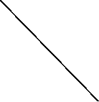

T



G



F

Figure 3.2: Single Line Diagram

The power system was simulated using the SimPowerSystems toolbox in Simulink by MathWorks. A snapshot of the model used to obtain the training and test dataset is shown in Figure 3.3. Three-phase VI measurement blocks are used to measure voltage and current samples. The transmission line is 100 km long, and the three-phase fault simulator is used to simulate various types of faults at different locations along the line with varying fault resistances.

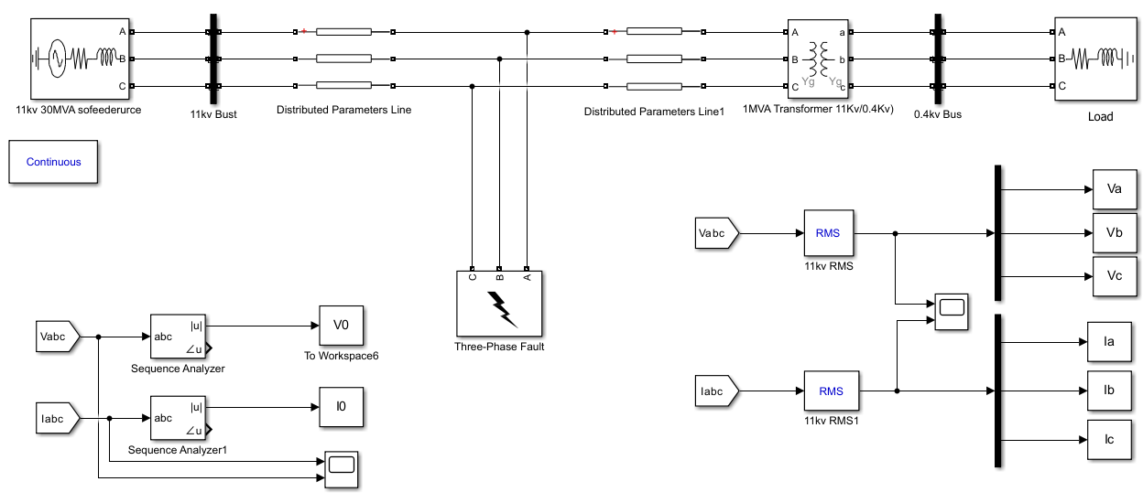

Figure 3.3: Snapshot of the studied model in SimPowerSystems.

The values of the three-phase voltages and currents are measured and modified accordingly and are ultimately fed into the neural network as inputs. The SimPowerSystems toolbox has been used to generate the entire set of training data for the neural network in both fault and non-fault cases.

Faults can be classified broadly into four different categories:

* Line-to-ground faults (L-G)
* Line-to-line faults (L-L)
* Double-line-to-ground faults (L-L-G)
* Three-phase faults (L-L-L)
* Three-phase-to-ground faults (L-L-L-G)

## 3.5. Flow Chart

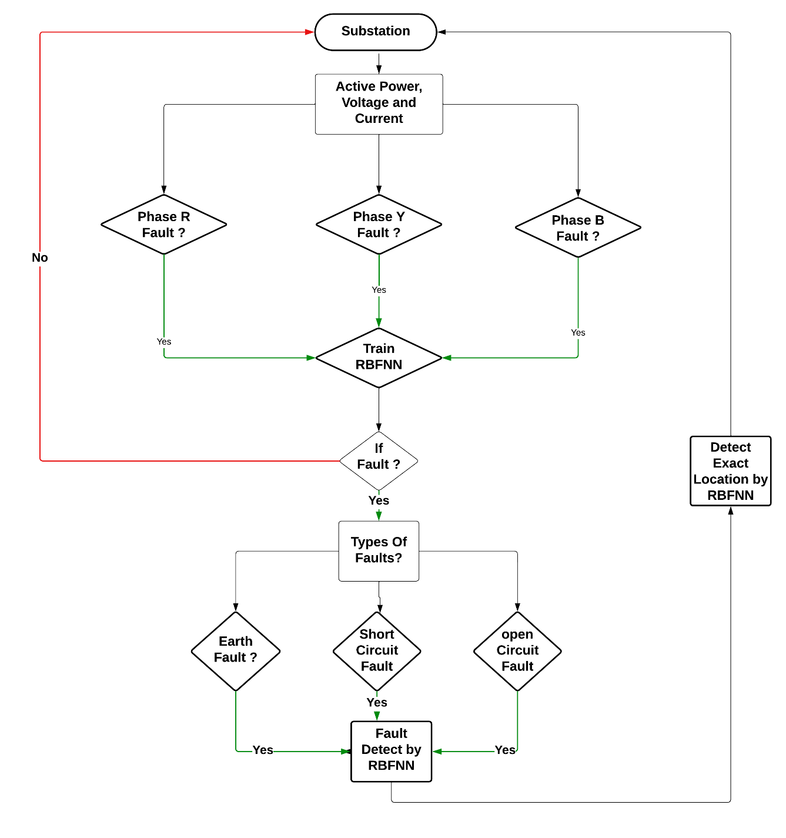

Figure 3.4: Flow Chart (field Study, 2024)

In this project we design, develop, test and implement a complete strategy for the fault diagnosis as shown in Figure 3.4 I nitially, the entire data that is collected is subdivided into two sets namely the training and the testing data set.

The first step in the process is fault detection. Once we know that a fault has occurred on the transmission line, the next step is to classify the fault into the different categories based on the phases that are faulted. Then, the third step is to pin-point the position of the fault on the transmission line. This paper sets out to propose an integrated method to perform each of these tasks using artificial neural networks. A backpropagation-based neural network has been used for fault detection and another similar one for fault classification. For each of the different kinds of faults, separate neural networks have been employed for the purpose of fault location. Each of these steps has been depicted in the flowchart shown in Figure 3.4

## 3.6. Data Pre-Processing

Reducing the size of the neural network improves its performance, which can be achieved through feature extraction. This process ensures that all important and relevant information from the voltage and current waveforms is effectively used. 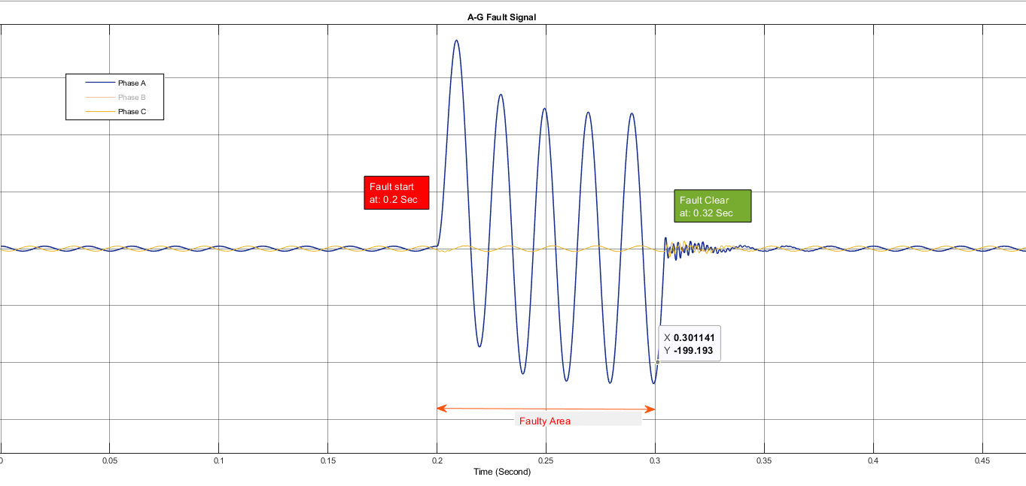**Figure 3.5: Signal Of A-G fault**

Voltage and current waveforms are generated and sampled at a frequency of 50 Hertz. The samples of voltage and current for all three phases, along with the corresponding pre-fault values, are recorded. This preprocessing step helps in capturing the essential features of the signals, making the neural network training more efficient and accurate. By focusing on key features, the network can achieve better fault detection and classification performance.

# CHAPTER FOUR

# WORK SCHEDULE

The work schedule consists of several topics that we would be working on throughout the project development phase. The Gant Chart representing our work schedule in a total span 12 weeks are:

**Week 1-3:**

* At the beginning of the project development phase, we will begin with research on different articles and journals.
* At the beginning of the second week, we will also begin preparing documentation during this time.

**Week 4-6:**

* We will start getting familiar with MATLAB Simulink Tools and ANN model and training process.

**Week 7-9:**

* Implementing and testing the initial Artificial Neural Network (ANN) model for underground cable fault detection using MATLAB Simulink.
* Refining and optimizing the ANN model based on the preliminary testing results.
* Collecting and analyzing data from simulated fault scenarios to validate the ANN model's effectiveness.

**Week 10-12:**

* Fine-tuning the ANN model parameters and architecture for improved accuracy in detecting different types of faults in underground cables.
* Developing algorithms or methods to enhance fault localization and classification within the cable network.
* Documenting and summarizing the research findings, methodologies, and outcomes obtained during the project development phase.
* Preparing the final project report, including all necessary documentation, results, analysis, conclusions, and recommendations.

# CHAPTER FIVE

## 5.1. Gantt Chart

Figure 5.1: Gantt chart of Work Schedule (Field Work 2024)

# CHAPTER SIX

# BUDGET

Figure 6.1: Budget Plan (field work 2024)

# CONCLUSION

# OUTCOME

The outcomes of this project have established a robust and accurate fault detection system using RBFNN technology for underground transmission lines, ensuring better reliability and enabling quick response. The system has been designed to identify specific types of faults, providing additional information about the issues.

In this project, the modeling of the neural network has been completed successfully, and the data collection process has been carried out effectively. The methods employed utilize the phase voltages, phase currents, zero sequence current and zero sequence voltage (scaled with respect to their pre-fault values) as inputs to the neural networks. Various types of faults, including single line-ground, line-line, double line-ground, and three-phase faults, have been considered in this work, with separate RBFNNs proposed for each fault type.

All the neural networks investigated in this project are based on the Radial Basis Function Neural Network (RBFNN) architecture. A fault location scheme for the transmission line system, from fault detection to fault location, has been successfully devised using artificial neural networks.

The simulation results demonstrate that all the proposed neural networks generally achieve satisfactory performance. As further illustrated, depending on the application of the neural network and the size of the training data set, the size of the ANN (including the number of hidden layers and neurons per hidden layer) varies. The importance of selecting the most appropriate ANN configuration to achieve the best network performance has been emphasized in this work. The sampling frequency used for sampling the voltage and current waveforms in this project is just 50 Hz, which is very low compared to what has been used in the literature (2 kHz – 5 kHz). This is significant because the lower the sampling frequency, the lesser the computational burden on the industrial PC that uses the neural networks. This translates to substantial energy savings, as continuous online detection schemes of this kind consume a large amount of energy, a major portion of which is due to the continuous sampling of waveforms. These improvements represent some significant advancements offered by this project over existing neural network-based techniques for transmission line fault location.

MATLAB R2022a, along with the SimPowerSystems toolbox in Simulink, was used to simulate the entire power transmission line model and to obtain the training data set. The performance of the neural networks was analyzed using the Artificial Neural Networks Toolbox extensively.

As a possible extension of this work, it would be beneficial to analyze all possible neural network architectures and provide a comparative analysis of each architecture and their performance characteristics. Possible neural network architectures that could be analyzed, in addition to radial basis neural networks, include support vector machines (SVM) networks and back-propagation neural networks.

# CHAPTER SEVEN

# REFERENCES

[1] Hadi Zayandehroodi student Member, IEEE, Azah Mohamed Senior Member, IEEE, Hussain Shareef Member, IEEE, Marjan Mohammadjafari

[2] Glover, J. D., & Sarma, M. S. Power System Analysis and Design. Cengage Learning. (2010).

[3] Wildi, T. Electrical Machines, Drives, and Power Systems. Pearson Education. (2013).

[4] Sarma, M. S. Electric Machines and Power Systems. Oxford University Press. (2015).

[5] Gonen, T. Electric Power Distribution System Engineering. CRC Press. (2017).

[6] Sun, J. Electric Power System Basics for the Nonelectrical Professional. Wiley. (2012).

[7] L. Yu*, et al.*, "Multistage RBF neural network ensemble learning for exchange rates forecasting," *Neurocomputing,* vol. 71, pp. 3295-3302, 2008.

[8] IEEE IRI 2011, August 3-5, 2011, Las Vegas, Nevada, USA 978-1-4577-0966-1/11/$26.00 ©2011 IEEE.

[9] C.C. Nnobi-Okoye and A. C. Igboanugo, "Predicting water levels at Kainji Dam using artificial neural networks", Nigerian Journal of Technology Vol. 12, No.1, pp. 129 – 136,

March 2013.

[10] Wood, A. J., & Wollenberg, B. F.. Power Generation, Operation, and Control. John Wiley & Sons. (2012)

[11] Kundur, P. Power System Stability and Control. McGraw-Hill Education. (1994).

[12] Bergen, A. R., & Vittal, V. Power Systems Analysis. Prentice Hall. (2000).

[13] Abur, A., & Exposito, A. G. Power System State Estimation. CRC Press. (2004).

[14] Ebha K, Anamika J, Thoke A.S, Abhinav J, Subhojit G, Detection and Classification of Faults on Six Phase Transmission Line Using ANN, International Conferencee.

[15] Kothari, D. P., & Nagrath, I. J. Modern Power System Analysis. Tata McGraw-Hill Education. (2008).

[16] Sabri Salman Altaie, A.; Asumadu, J., "Fault detection and classification for compensating network using combination relay and ANN," in Electro/Information Technology (EIT), IEEE International Conference, pp. 351 - 356, May 2015.

[17] Basler M.J, Schaefer, R.C., Understanding power system stability, Protective Relay Engineers, 58th Annual Conference for vol. 2, pp. 46-67, April 2005.

[18] Sushma G, Analysis of Fault location methods on transmission Lines, University of New Orleans, pp. 1 79. May 2014.

[19] Zimmermann H.-J.: ‘Fuzzysets, decision making, and expert systems’ vol. 10 (Springer Science & Business Media, 2012).

[20] Cotes, C. and Vapnik, V. “Support Vector Networks,” 273-297(1995).

[21] A. W. Salami, A. A. Mohammed, J. A. Adeyemo and O. K. Olanlokun, "Modeling of reservoir inflow for Hydropower Dams using Artificial Neural Network", Nigerian Journal of Technology, Vol. 34, No. 1, January 2015.

[22] Mayank Banaula, “Classification in Machine Learning” Lesson 9-38

[23] [Online] Available: https://mouswayt.blogspot.com/2021/04/automatic-power-line-fault-detector.html, 2021.

[23] D.S Broomhead and D Lowe Multivariate functional interpolation and adaptive networks Complex Systems ,331-355 ,1988

# Appendix 1

* Single line diagram of IEEE 34-bus test feeder:

